North Lincolnshire Council
Daily Event Analysis
12th November 2010

Overview

The Dawes Lane Coke Oven (DLCO) Osiris measured a daily mean PM₁₀ concentration of 84µg/m³ on Friday the 12th November 2010 exceeding the allowed 50µg/m³ as a daily mean. A check of the data has revealed that concentrations of PM₁₀ were above the 50µg/m³ between 00:00 and 06:00 (circled in red on the graph). During this 6 hour period concentrations at the DLCO Osiris measured a mean concentration of 97µg/m³. The Low Santon TEOM measured a daily mean concentration of 57µg/m³. The Low Santon TEOM measured a mean concentration of 39µg/m³ during the 6 hour focus period.

Between 14:00 and 17:00 (circled in light blue on the graph) the concentrations of both the DLCO Osiris and the TEOM were above the 50µg/m³ threshold. During this 3 hour period of focus the Low Santon TEOM measured a mean concentration of 119µg/m³ and the DLCO Osiris measured a mean concentration of 73µg/m³.

Met Conditions

Consistent Westerly winds were observed throughout the day. The wind during the 6 hour period of focus ranged between 255° and 263°. Wind speeds averaged at 5 m/s. The period of focus averaged at 7m/s. The highest wind speed in this period was 8.2m/s in which the concentration of PM₁₀ reached 91µg/m³. Rain was observed throughout the day.

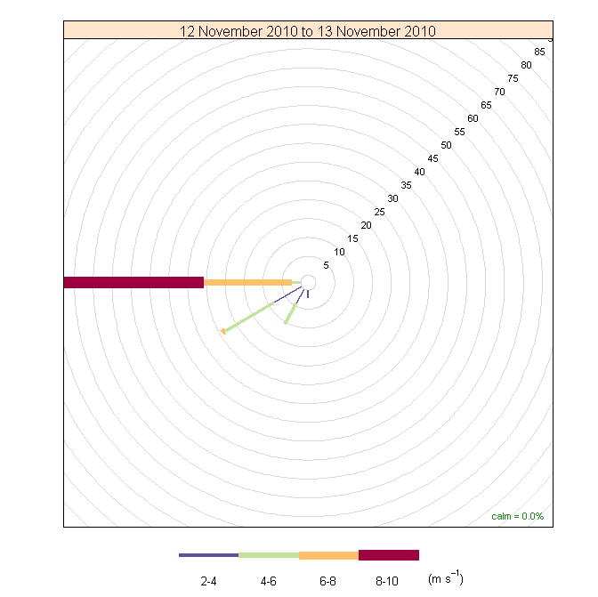

Episode Wind Range 00:00- 06:00

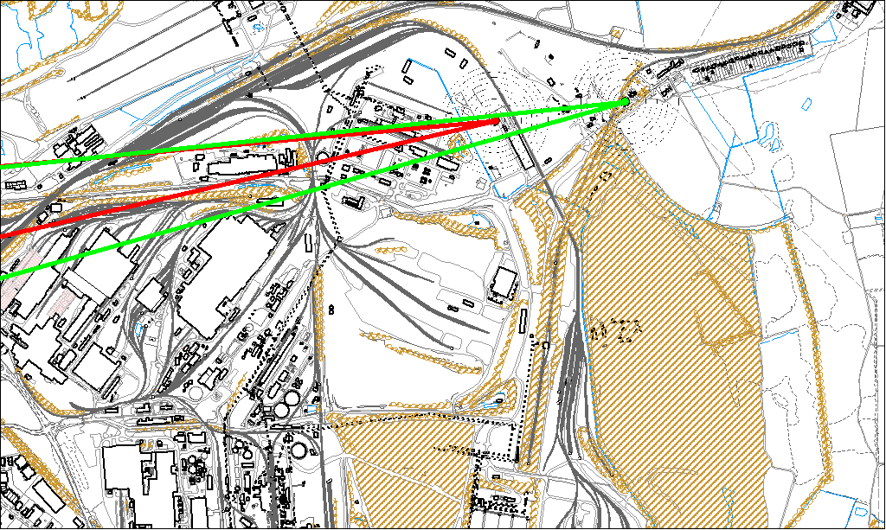

Potential Sources

The above map shows the Low Santon TEOM (indicated by the green lines) and the DLCO Osiris (indicated by the red).

As the DLCO Osiris measured consistently higher concentrations during this period, it is likely that the TEOM was affected by a different source to the DLCO Osiris. Therefore, the red wind area within the green is likely to contain the source of the exceedence.

The likely areas include;

- Dawes Lane Coke Ovens

Episode Wind Range 14:00-17:00

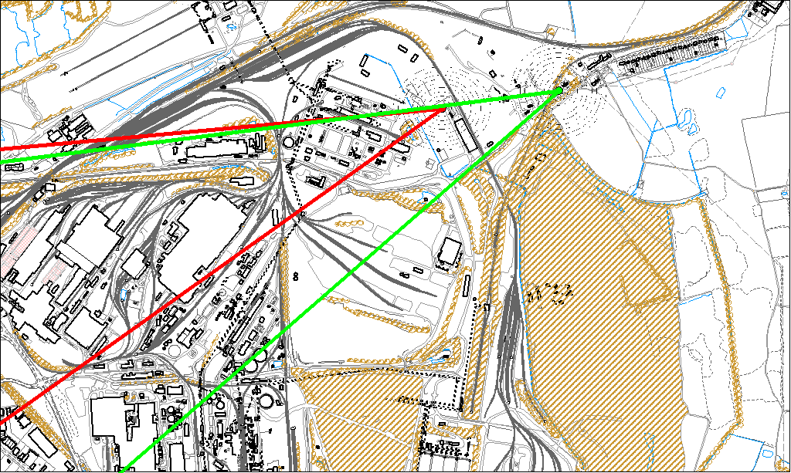

The above map shows the Low Santon TEOM (indicated by the green lines) and the DLCO Osiris (indicated by the red).

As the Low Santon TEOM measured consistently higher concentrations during this period, it is likely that the Osiris was affected by a different source to the Low Santon TEOM. Therefore, the green wind area excluding the red is likely to contain the source of the exceedence. There is a spike in the Osiris data the source of which is likely to be the Dawes Lane Coke Ovens.

The likely areas include;

- Redbourn Stocking Area
- Tarmac
- Dawes Lane Coke Ovens

